Judul : Menghitung Nilai Akhir Mahasiswa INF

Nama : Nurul Ulfa Ashilah

NIM : J3C117068

**TUGAS 1**

Form :

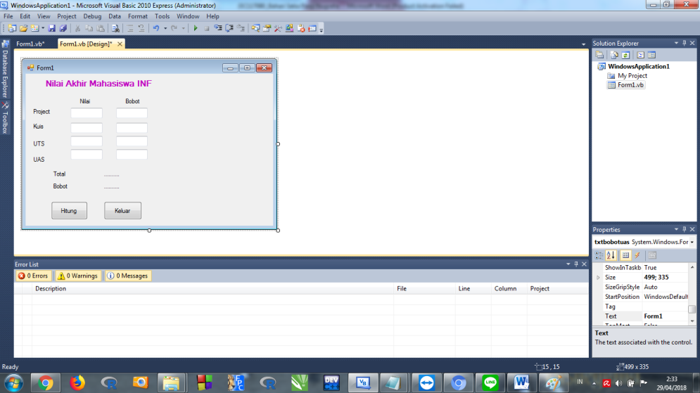

Saat dimasukkan nilai :

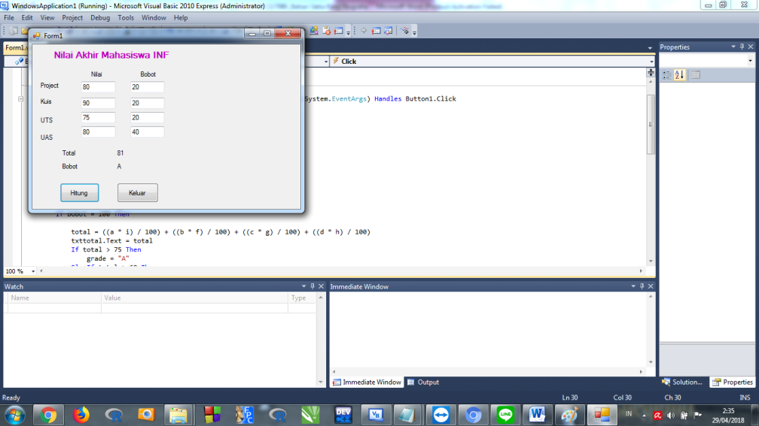

Program :

Public Class txtbobotuas

Private Sub TextBox1_TextChanged(ByVal sender As System.Object, ByVal e As System.EventArgs) Handles txtproject.TextChanged

End Sub

Private Sub Button1_Click(ByVal sender As System.Object, ByVal e As System.EventArgs) Handles Button1.Click

Dim a, b, c, d, i, f, g, h, bobot, total As Single

Dim grade As String

a = txtproject.Text

b = txtkuis.Text

c = txtuts.Text

d = txtuas.Text

i = txtbobotproject.Text

f = txtbobotkuis.Text

g = txtbobotuts.Text

h = bobotuas.Text

bobot = i + f + g + h

If bobot = 100 Then

total = ((a * i) / 100) + ((b * f) / 100) + ((c * g) / 100) + ((d * h) / 100)

txttotal.Text = total

If total > 75 Then

grade = "A"

ElseIf total > 60 Then

grade = "B"

ElseIf total > 40 Then

grade = "C"

ElseIf total > 20 Then

grade = "D"

Else

grade = "E"

End If

txtgrade.Text = grade

Else

MsgBox("Nilai Bobot Salah", MsgBoxStyle.Exclamation)

End If

End Sub

End Class